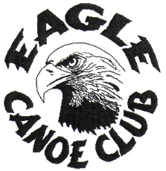
Mission Statement and Club Values

Mission Statement
To provide a friendly welcoming club, where all paddlers can develop in a safe and fun environment.

Club Values
Friendly
Approachable
Inclusive
Supportive and Encouraging
Enjoyable and Fun
Offers a range of opportunities
Inspiring

